Title : TransformGov Talks : Our October 2026 London event!
Hi everyone,
Our latest event, our 20th, took place at the Ministry of Justice (and online!) on 28 October 2026.
Brought to you by our excellent sponsors GovCamp, dxw, TPXimpact, Ceva, Public.Digital, Holistic Agility, State of the Future and Agile.
Hosted by Gavin Freeguard, Director, State of the Future.
Our first speaker was Asma Nafees, NHS Non-Exec Director, Local Authority Social Enterprise NED and Social Care Charity Trustee, on “Leadership Without Borders: Challenging the Way We Do Public Service”.
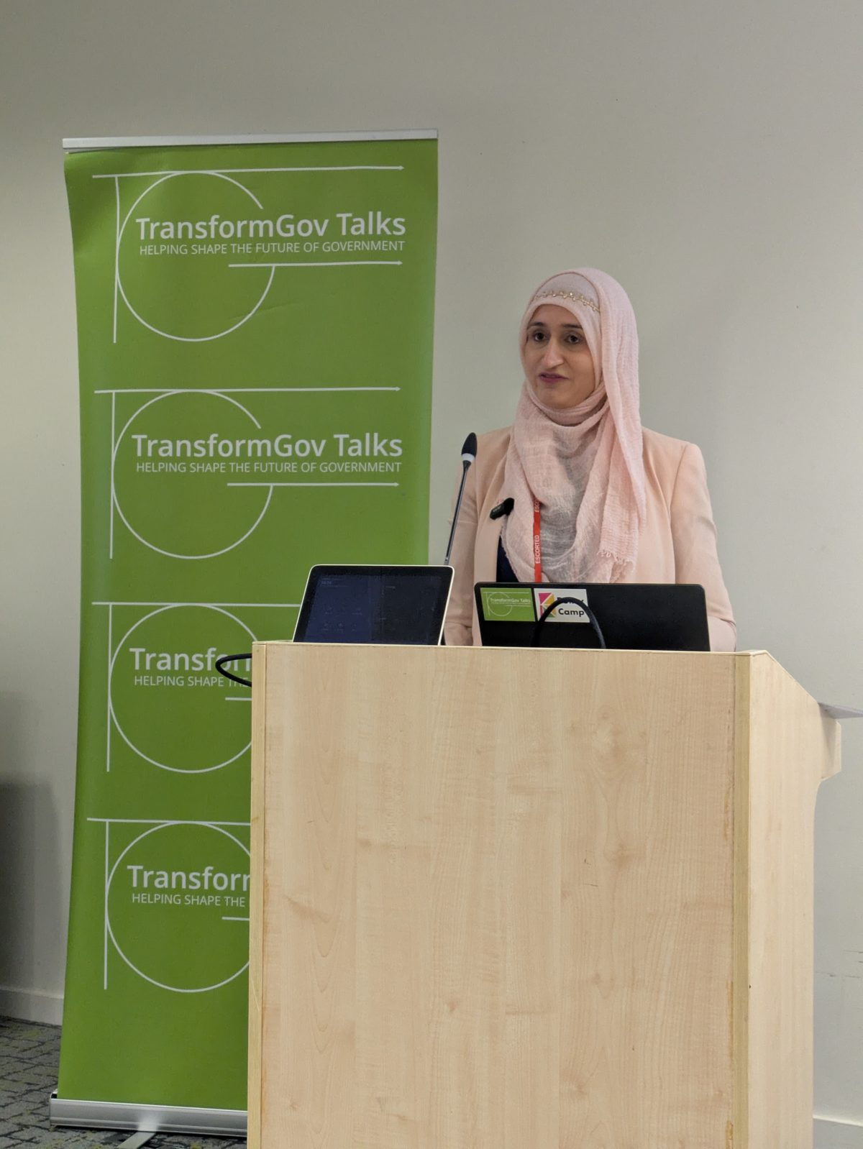
Asma Nafees
Our second speaker was Harry Trimble, dxw, on prototypes exploring what data and automation in a blueprint for government could be like.
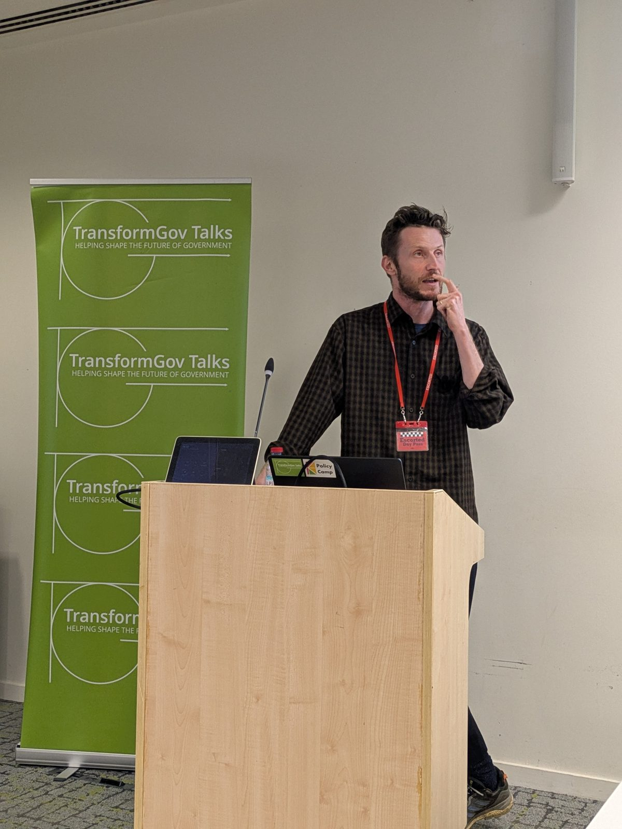
Harry Trimble
If you weren’t able to attend, you can catch up on the event in more detail:
Read the Gemini AI Summary
Video on YouTube
Listen on Spotify or Apple Podcasts
At the end of the event, we included a few parish notices for other events and projects you might be interested in:
Policy Camp (report now published)
National Conversations
Civic Punks
Data Bites
The National Strategy Project
GovCamp Cymru (6 November)
Open Data Camp (21–22 November)
You can also download this poster to put up in your office. If you do — please share a photo with us!
Let us know if you have an event you’d like us to publicise.
Finally, our next event is on 25 November 2026, 6-7pm, at the Ministry of Justice, featuring Peter Thomas (civilservicereformuk.com) on what 15 years of GDS tell us about successful reform, and Tom Wynne-Morgan and Jack Strachan (Government Digital Service) on CustomerFirst, with another speaker to be confirmed.
You can register now!

